Abstract

The study was conducted to investigate the seasonal variation in water quality of the Padma River in order to assess the status of the river water quality. The Padma River is the main source of freshwater and fisheries resources to the southwest region of Bangladesh. The result showed that the highest temperature(29oC), exceeding the standard level for aquatic environments, was found during the wet season. The highest TDS (160 mg/l) and EC (303.33 mg/l) was found during the wet season that exceeded the standard level for aquatic environment. The highest pH (7.9) was found during the wet season in ST-3. On the other hand, the highest DO (12 mg/l) and BOD (3.66 mg/l) was observed during wet season while the highest alkalinity (389 mg/l) and hardness (160 mg/l) were found during dry and wet season, respectively.

**1.1 Study Area and Sampling Site**

The study was conducted in the Padma River of Bangladesh. The Padma is the second longest river of Bangladesh (Hossain et al., 2005). It is the main distributary of the Ganges which originates in the Gangotri glacier of the Himalayan. The part of the Ganga in Bangladesh is known as the Padma which enters Bangladesh from India (Murshidabad district) at Shibganj Upazila (Manakosha and Durlavpur unions) of Chapai Nawabganj district. Its length in Bangladesh is 366 kilometers (Hossain et al., 2005). The Padma is joined by the mighty Jamuna (Lower Brahmaputra) and the resulting combination flows with the name Padma further east, to Chadpur. Here, the widest river in Bangladesh, the Meghna, joins the Padma, continuing as the Meghna almost in a straight line to the south, ending in the Bay of Bengal (Zareen et al., 1999). Main stream goes through Chapai Nawabganj, Rajshahi, Pabna, Kushtia, Faridpur, Rajbari and Chandpur districts of Bangladesh. But according to Chowdhury (2003) the river from Goalanda to Chadpur is named Padma which is 120 kilometers long and 4-8 kilometers width; and the river flows from Chapai Nawabganj to Goalanda, is the Ganga. However, drainage water from the adjacent urban areas are continuously polluting waters in the Padma River posing a serious threat to its ecosystem and biodiversity.

**Table 1.2**. Description of the sampling location of the Padma River.

|  |  |  |
| --- | --- | --- |
| Stations | Local name | GPS Coordinate |
| S-1 | Aricha Ghat | ; |
| S-2 | Gorur Hatt | ; |
| S-3 | Alal Board Mill | 49'31.89"N;46'56.84"E |

|  |
| --- |
|  |
|  |  |

**Fig. 1.3 Map showing the study area of Padma River, Bangladesh**

**1.4 Seasonal variation and comparison with standard**

**1.1.1 Water Temperature**

Temperature is an important factor which can determine the allowable limit for other parameters. It affects the solubility, and in turn, the toxicity of many other quality parameters. Human activities causing the change of water temperature should not be beyond natural seasonal fluctuations. Otherwise, it can disrupt aquatic ecosystem 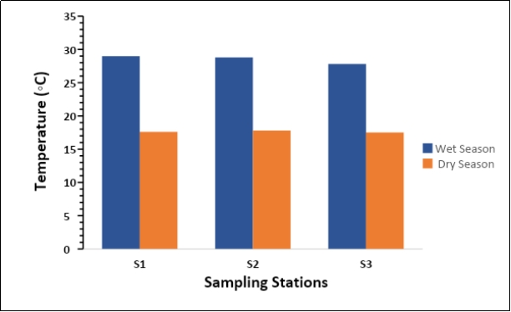(EGISII, 2002).

**Fig. 1.2**Temperature in different stations between two seasons of the Padma River.

The mean temperature in wet season was found 28.53°C and ranging from 29°C to 27.8°C. On the other hand, the mean temperature in dry season was found 17.3° C and ranged from 17°C to 17.5°C. Moreover, mean water temperature was found 23.08°C during wet and dry season. In case of river water temperature, the DoE standard for sustaining aquatic life is within 20°C to 30°C both in wet and dry season (Bhaumik *et al*., 2006). The result of the study showed that water temperature of the Padma River of all sampling stations was closed to the suitable limit. Temperature of investigated river was found to be more or less similar to the Bangladesh and international rivers. Temperatures of Gorai River, Shitalakhya River, Nile River of Egypt and Seybouse River of Algeria found 26.98°C, 27.79°C, 23.5°C and 20.08°C, respectively (Shammi *et al*., 2022; Kabir *et al*., 2020; EI-Sayed *et al*., 2020; Guettaf *et al*., 2014) were observed more or less similar to the present investigated river.

**Table 4.1:** Seasonal variation of temperature among sampling stations in comparison with standard levels.

|  |  |  |  |  |  |
| --- | --- | --- | --- | --- | --- |
| Sampling site | Wet season | | Dry season | | Standard levels  (ECR, 1997; EPA, 2001) |
| Avg. (N=3) | Range | Avg. (N=3) | Range | Fishing |
| ST-1 | 29 | 27-29 | 17.6 | 17-18 |
| ST-2 | 28.8 | 17.8 |
| ST-3 | 27.8 | 17.5 | 25 |
| Mean±SD | 28.53±0.64 | 17.63±0.15 |

**4.1.2 Color and Odor**

Color and odor of the Padma River was observed by visually. The observed colors of all the sampling stations were slightly black in wet season and colorless in dry season. The odor of the river water was found slightly bad in all stations during wet season whereas the condition was found a bit improved in dry season. Most of these observation match those made during the current investigation.

**4.1.5. pH**

The pH indicates the acidity or alkalinity of a water body. One of the significant environmental impacts of pH is its effects on the solubility and therefore the bioavailability of other substances. The process is important in surface water: runoff from agriculture, domestic and industrial areas may contain iron, ammonia, lead, chromium, mercury and other elements. The pH of water affects the toxicity of these substances become more soluble and thus available for absorption. The normal range for pH in surface water systems is 6.5 to 8.5 (ECR, 1997; Das, 1997)